Data Analytics Internship
Task : 1
Data visualization (Iris dataset)

Submitted By:
- Name : Thodeti Nagaveni
- College : Sri Padmavathi Mahila viswavidhyalayam , SOET
- Branch: Computer Science and Engineering
- Roll Number: 2371062

Organization:
@codealpha
Submission Date:29/07/2026

Introduction:
Data Visualization is the process of converting raw data into graphical representations such as charts and graphs. It helps users understand complex information quickly by presenting data visually. Instead of analyzing large tables of numbers, visualizations make it easier to identify patterns, trends, relationships, and outliers.
In this project, the Iris dataset was visualized using Python libraries such as Pandas, Matplotlib, and Seaborn. Different types of graphs were created to better understand the characteristics of the dataset and demonstrate how visualization supports data analysis and decision-making.
Objective:
The main objectives of this project are:
- To understand the importance of data visualization.
- To visualize the Iris dataset using Python.
- To create different types of graphs for better data understanding.
- To identify patterns and relationships among the dataset features.
- To present data in a clear and meaningful graphical format.
About the Dataset:
The Iris dataset is one of the most popular datasets used in data analytics and machine learning. It contains measurements of iris flowers belonging to three different species.
Dataset Information:
- Dataset Name : Iris Dataset
- File Format : CSV
- Number of Records : 150
- Number of Columns: 5
Dataset Features: The Iris dataset contains the following features:
- Sepal Length: Represents the length of the sepal in centimeters (cm).
- Sepal Width: Represents the width of the sepal in centimeters (cm).
- Petal Length: Represents the length of the petal in centimeters (cm).
- Petal Width: Represents the width of the petal in centimeters (cm).
- Species: Represents the type of Iris flower. The dataset contains three species: Setosa, Versicolor, and Virginica.

Tools and Technologies Used:
Tool / Technology | Purposess
Python | :Programming language used to develop the project
Visual Studio Code | :Code editor used to write and execute Python code
Pandas | :Used to load and manage the dataset
Matplotlib | :Used to create basic charts and graphs
Seaborn | :Used to create attractive and informative statistical visualization
Project Methodology
The project was completed using the following steps:
Step 1: Dataset Selection
The Iris dataset was selected because it is simple, clean, and suitable for beginners learning data visualization.
Step 2: Dataset Loading
The dataset was loaded into Python using the Pandas library.
Step 3: Importing Required Libraries
The required Python libraries were imported:
- Pandas
- Matplotlib
- Seaborn
Step 4: Creating Visualizations
Different graphs were created to understand the dataset visually.
Step 5: Analysis
Each graph was analyzed to identify patterns and relationships among the features.
Python Libraries Used
Pandas
Pandas is used to read the CSV file and organize the dataset into a structured format called a DataFrame.
Matplotlib
Matplotlib is a Python visualization library used to create charts such as histograms, bar charts, and line plots.
Seaborn
Seaborn is built on top of Matplotlib and provides attractive statistical visualizations like heatmaps, box plots, and scatter plots.
Visualizations:
Histogram:
Purpose:
The histogram displays the distribution of numerical values in the dataset.
Observation:
- Most feature values are concentrated around the middle range.
- The distribution helps understand how the data is spread across different values.
Output graph:
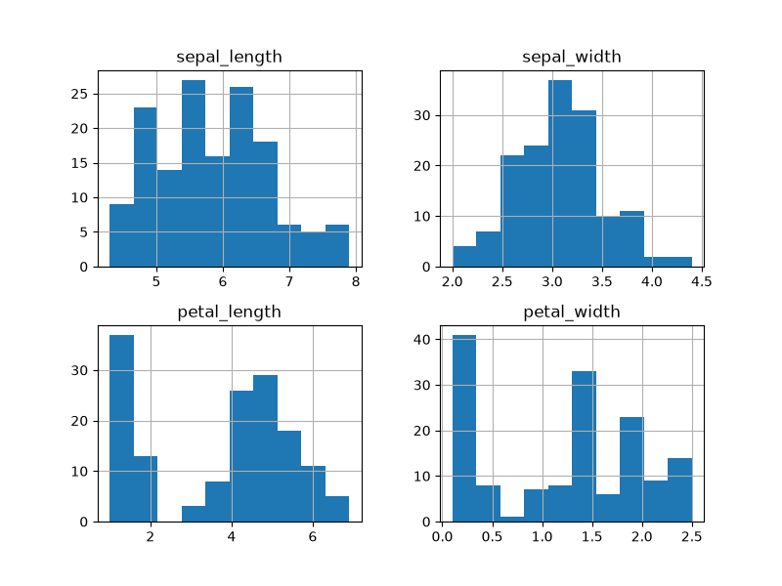
Box Plot:
Purpose:
The box plot is used to identify outliers and understand the spread of the data.
Observation:
- Most values lie within the normal range.
- A few outliers are visible in some features.
Ouput graph:
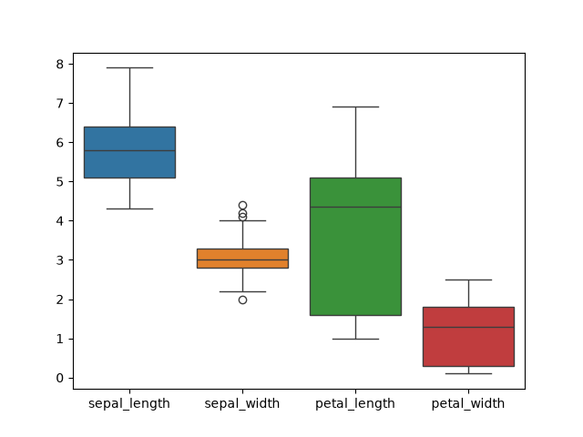
Scatter Plot:
Purpose:
The scatter plot shows the relationship between sepal length and petal length while distinguishing flower species.
Observation:
- The three Iris species form distinct clusters.
- Petal length generally increases with sepal length.
Output graph:
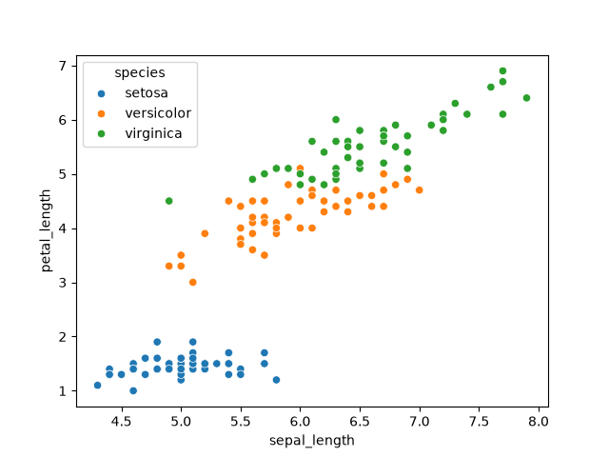
Heatmap:
Purpose:
The heatmap shows the correlation between numerical features.
Observation:
- Petal length and petal width have a strong positive correlation.
- Sepal measurements show weaker correlations compared to petal measurements.
Output graph:
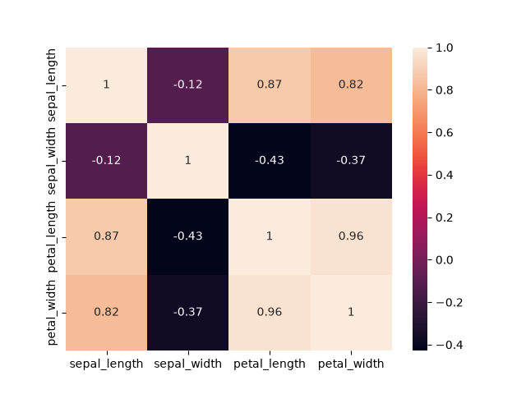
Bar Chart:
Purpose:
The bar chart displays the number of samples in each Iris species.
Observation:
- Each species contains 50 samples.
- The dataset is balanced across all three classes.
Output graph:
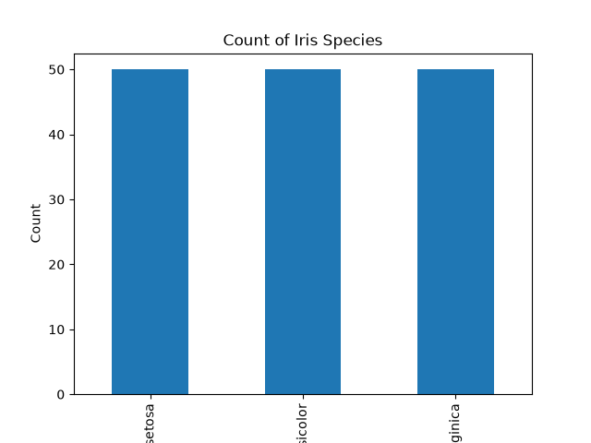
Results:
The visualizations provided a clear understanding of the Iris dataset. They highlighted the distribution of values, relationships between features, class balance, and potential outliers. The charts made the dataset easier to interpret compared to viewing raw numerical data.
Conclusion:
The Data Visualization project was successfully completed using Python, Pandas, Matplotlib, and Seaborn. The Iris dataset was visualized through different charts, including a histogram, box plot, scatter plot, heatmap, and bar chart. These visualizations made it easier to understand feature distributions, detect outliers, identify correlations, and compare flower species. Overall, the project demonstrated how effective data visualization supports data analysis and helps communicate insights clearly.

